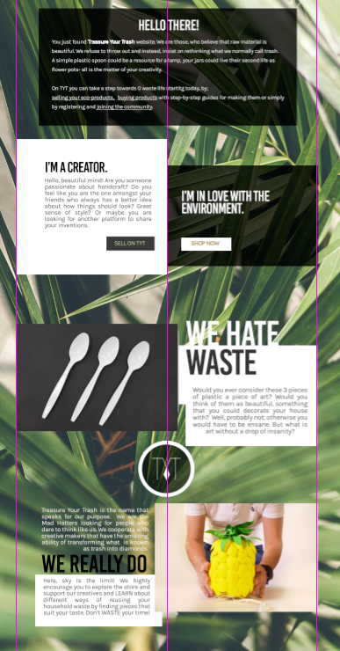

You just found Treasure Your Trash website. We are those, who believe that raw material is beautiful. We refuse to throw out and instead, insist on rethinking what we normally call trash.

A simple plastic spoon could be a resource for a lamp, your jars could live their second life as flower pots- all is the matter of your creativity.

On TYT you can take a step towards 0 waste life starting today, by;

selling your eco-products, buying products with step-by-step guides for making them or simply by registering and joining the community.

2.

Would you ever consider these 3 pieces of plastic a piece of art? Would you think of them as beautiful, something that you could decorate your house with? Well, probably not; otherwise you would have to be insane. But what is art without a drop of insanity?

3.

Treasure Your Trash is the name that speaks for our purpose. We are the Mad Hatters looking for people who dare to think like us. We cooperate with creative makers that have the amazing ability of transforming what is known as trash into diamonds.

Here, sky is the limit! We highly encourage you to explore the store and support our creatives and LEARN about different ways of reusing your household waste by finding pieces that suit your taste. Don’t WASTE your time!

THE CREATOR

"For me, personally, there is no right or wrong when it comes to the environment. You either are a decent human being, or not. I craft with passion. With passion towards the environment."

